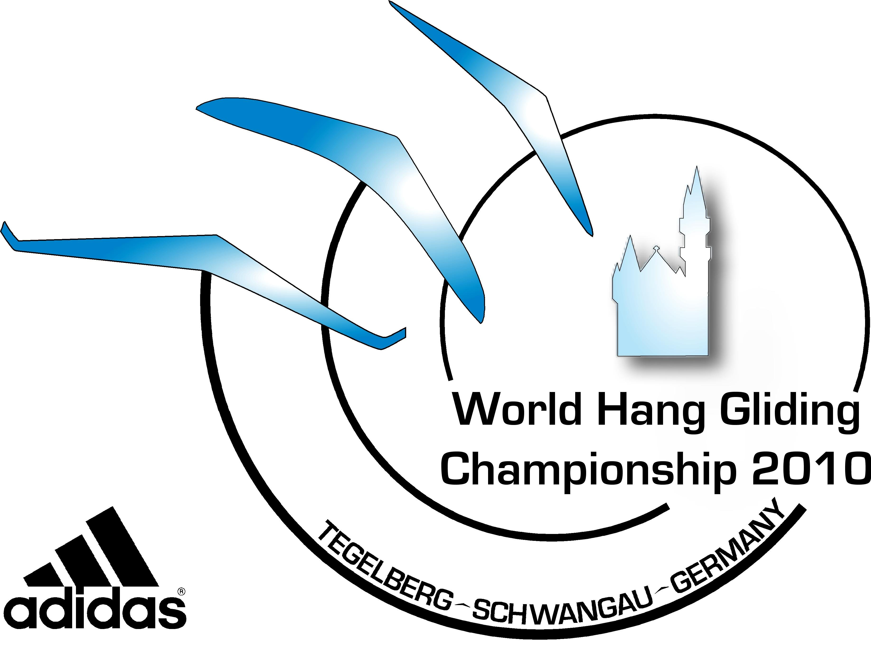12th FAI Women’s World Hang Gliding Championship 2010
18th FAI World Hang Gliding Class 2 Championship 2010
5th FAI World Hang Gliding Class 5 Championship 2010

TASK ADVISORY COMMITTEE (TAC) MEMBERS
Appointed: May, 2010

NAME: …………………………… NATION: …………..……………

NAME: …………………………… NATION: …………..……………

NAME: …………………………… NATION: …………..……………

SAFETY COMMITTEE MEMBERS
Appointed: May, 2010

NAME: …………………………… NATION: …………..……………

NAME: …………………………… NATION: …………..……………

NAME: …………………………… NATION: …………..……………

